Practical no. 23
Name :- Danish Altaf Solkar Enrolment no. :-24111590805
Class :- CO3K – B Subject :- DMS
Aim:- Implement PL/SQL program based on Exception Handling
(User-defined exceptions)

Program :-
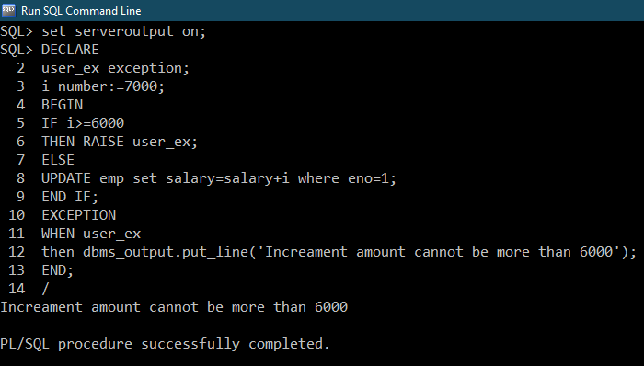

Program :-
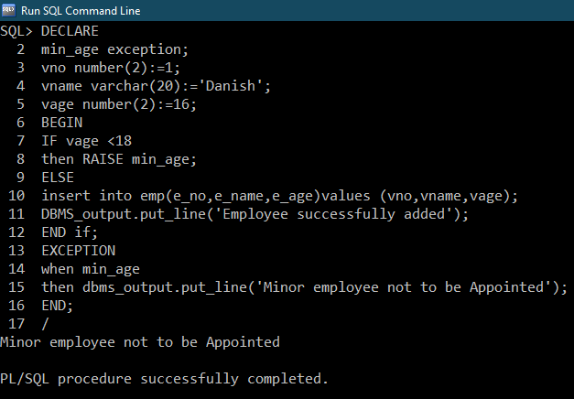
Program :-
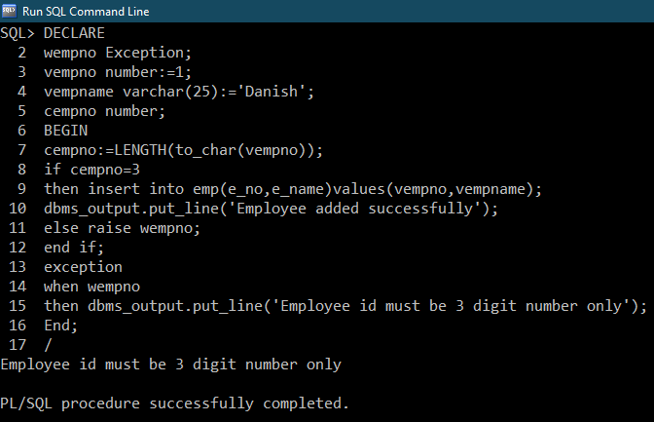

Exercise :-
Program :- 